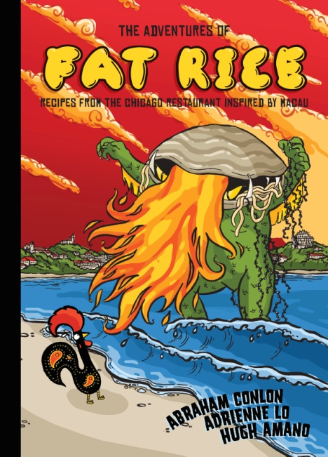**Lowell Native and Renowned Chef Abraham Conlon Returns to Cobblestones** to Celebrate the Release of his New Cookbook, THE ADVENTURES OF FAT RICE: *R****ecipes from the Chicago Restaurant Inspired by Macau***

On Saturday, December 17th, Cobblestones welcomes Abraham Conlon, co-owner of the celebrated Chicago eatery Fat Rice, to celebrate the release of his new cookbook **THE ADVENTURES OF FAT RICE**, recently hailed by the *Boston Globe* as one of the “season’s best cookbooks.” The cookbook-meets-comic book-meets-history lesson, which explores the food culture of Macau (a melting pot of Chinese, Portuguese, Malaysian, and Indian foodways), will be the inspiration for the Chef’s special at Cobblestones. Copies of the book will also be available for purchase throughout the evening.

**WHERE**

COBBLESTONES, 91 Dutton Street, Lowell, MA 01852

**WHEN**

Saturday, December 17th, 4:00 – 8:00pm

**COST**

Dinner: $25pp, Limited seating, reservations requested

Fat Rice Cookbook: $35 per signed copy

**RESERVATIONS**

Reservations can be made by calling the restaurant at (978) 970-2282.

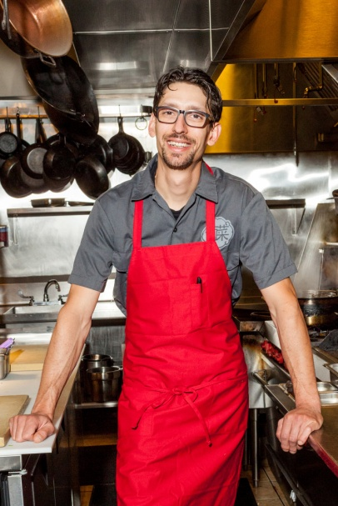

**ABOUT THE AUTHOR**

Abraham Conlon is the chef and co-owner, along with partner Adrienne Lo, of the popular Chicago restaurant Fat Rice. Together, they have received accolades from the James Beard Foundation, Bon Appétit, Food & Wine, Eater, and many others. Abe’s first job in the restaurant industry was at Cobblestones, where much of the foundation and training for his career was established, and where he was mentored by the late chef Ed Zaranski.